**xxxxxxxxxxxxxxxxxxxxxxxxxxxxxxxxxxxxxxxxxxxxxxxxx**

**15.5.2014**

**INSTRUCTIONS RELATED TO PROBLEM PROCESS TICKET:**

**PBI000000019017 Logica: McAfee installation has caused blue screens**

* These instructions are valid only to Logica OneIS workstation models Lenovo W520
* Cases where this is needed are originally related to change of antivirus software from F-Secure to McAfee
* With some cases this change caused blue screening which were resolved during problem processing
* There are 3 steps simply because the first might not necessarily help alone. Step 1 is the general fix which helps in most cases anyway
* Even workstations are supposed to be standard image installed and supported because they should be on the same update level, there still are end users who might have updated their workstations by themselves. These other steps are to ensure that most usual types of errors found during problem solving can be fixed.
* If steps 1-3 are not enough then you have run into an individual case which must be handled separately as such. Note! There has been even 1-3 workstation cases where motherboard had to be changed after BIOS update.
* Suggested “step 4” is to simply re-install workstation from the scratches

1. **BIOS UPDATE PROCEDURE**

* About pre-setup if workstation is not in docking station
  + Make sure end user’s workstation is connected to network with cable
  + Make sure workstation battery is attached and power chord is connected
* All applications must be closed
* BIOS update starts from here:

\\fi-ms002\LogicaSoftware\Lenovo_W520_BIOS_1.39_EN_UNI_W7_R01

* Follow this progress of the installation:

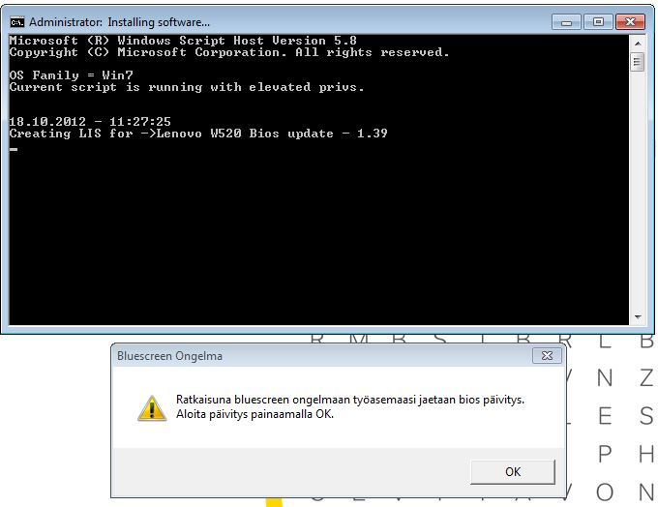

Press OK

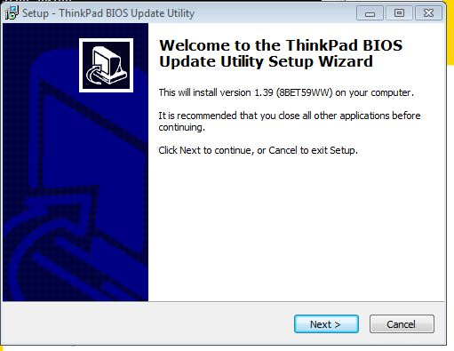

Press ”Next >”

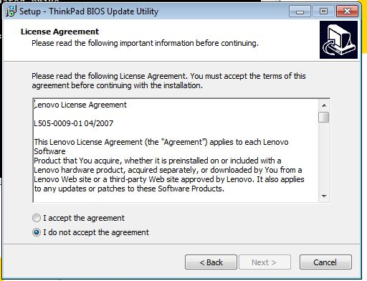

Choose ”I accept the agreement!” and then press“Next >”

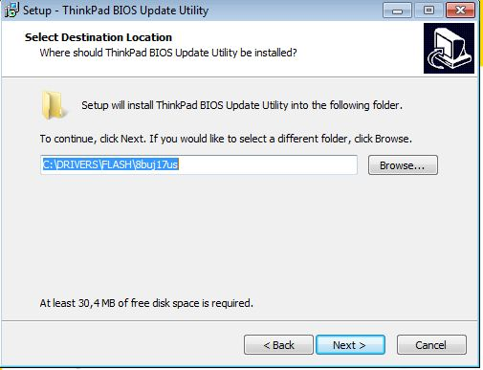

Press ”Next >” (Don’t change default path)

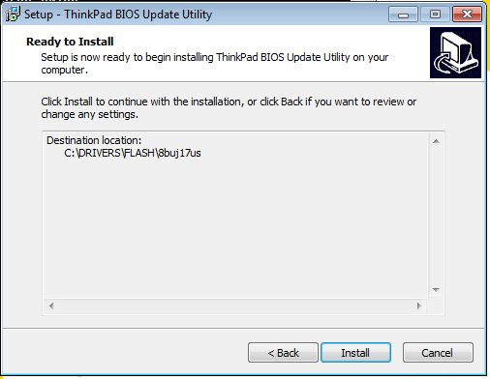

Press “Install”

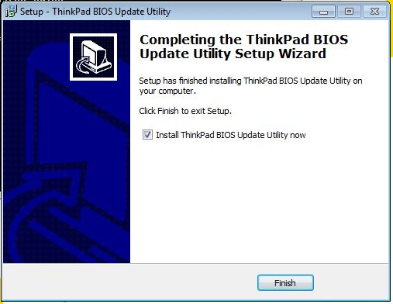

Leave check button as is and press “Finish”

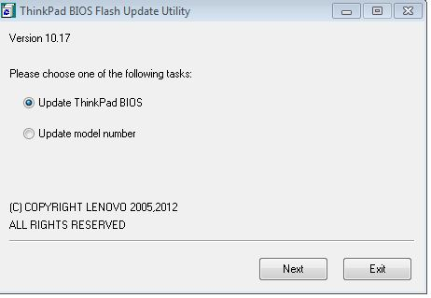

Leave check button as is and press ”Next”

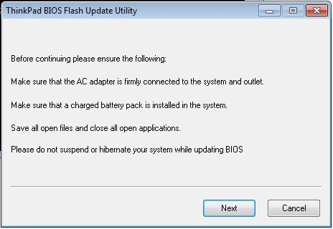

Press ”Next”

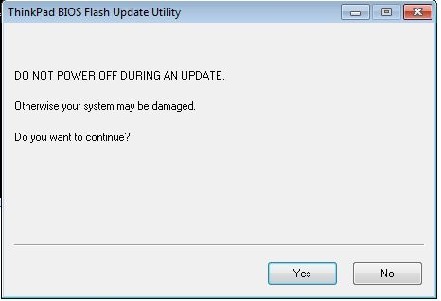

Press ”Yes”

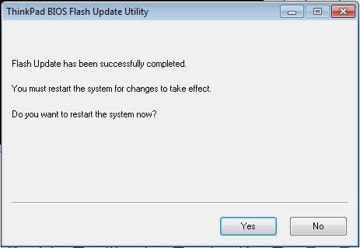

Press”Yes”

1. **IF YOU GET “INSTALL LOADER…” ERROR AFTER BIOS UPDATE**

* Procedure must be done with W520 in docking station and extra display attached to it
* Power on PC preparing to enter BIOS Setup
* press and hold ThinkVantage (blue) button
  + Choose F1 to enter BIOS setup pages
* Choose Config -tab
* Choose Display (enter)
* Do following changes:
  + Boot Display Device: leave as is (=ThinkPad LCD)
  + Graphics Device: change NVidia Optimus → Discrete Graphics
  + OS Detection… :  change Enabled →  Disabled
* Save the configuration with pressing F10 + Yes + Enter, do reboot when asked
* Let Windows start as usually
* When soon asked for restart , let the workstation finish it
* After the second reboot W520 should work OK again

1. **IF YOU GET BLUE SCREEN ERROR STILL (WITH or WITHOUT STEP 2)**

* Next step is to ask end user how he uses remote connections with VPN
* If end user explains he/she is using it only for accessing office network
  + You can advice the end user to start using the new Juniper connection method (explain where ordering details can be found)
  + Ask the end user to remove current CheckPoint application from the workstation
* If end user explains she/he is using Telescope connections for accessing customer environment
  + The version of CheckPoint needs to changed from R75 to non-firewall version R73 as following
  + You can ask end user to run this software package:

\\fi-ms002\LogicaSoftware\Checkpoint_EndpointConnect_5.41_EN_UNI_W7_R01

* + This link must be copied into “Search programs and files” (from Start button)
  + Click Install.cmd with right mouse button as to “Run as Administrator”

1. **IF STEPS 1-2 WON’T HELP**

* Image is updated recently to fill some/most of these steps earlier
* Re-install the workstation from image to ensure it meets standardization requirements in the first place.